Hi Mike

Here are two more series of Kodak back cards for you. They are drawn from my own obsessive collection of Australian Caves Postcards.

I also have:

A number that are clearly personal photos

A wonderful series of 15 cards – some of the finest photography of all – but have handwritten titles with occasional comments on the back (Sept 1935) and are clearly personal again.

Occasional cards from the top quality professional series of James H.A. MacDougall

A series from Ford Studios of Bunbury on either Harrington’s Empire back or Kodak backs

A single card with oval framed photo and title on negative

Let me know if you want details of any of the above.

In the meantime:

1. A series of unknown origin but appears to focus on the caves. They have a diverse range of backs but many have Kodak

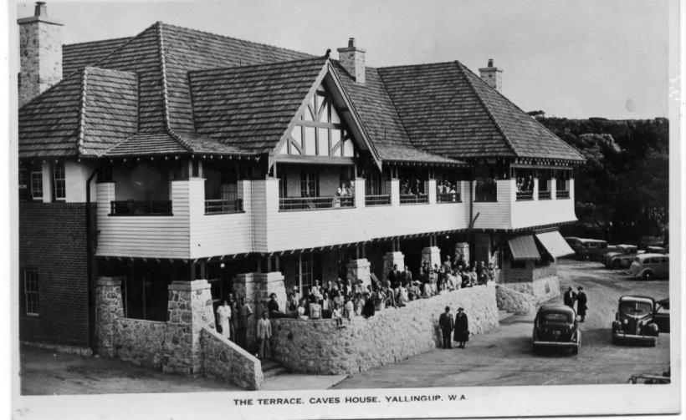

The Terrace, Caves House, Yallingup, W.A. H K-D
Lounge, Caves House, Yallingup, W.A. H K-D

Jewelled City, Yanchep Caves, W.A. H Printed
SAME Rubber-stamp
SAME Blank
Cabaret Cave, Yanchep, W.A. The Entrance H Rubber-stamp
SAME Blank
"Suspended Columns", Yanchep Caves, W.A. H Rubber-stamp
"The Elephant's Foot", Yanchep Caves, W.A. H Rubber-stamp
"The Shrine, Yanchep Caves, W.A. H K-D
SAME Blank
Interior Cabaret Cave, Yanchep, W.A. K-D
“The Octopus”, Yanchep Caves, W.A. K-D
“Fairy Land”, Yanchep Caves, W.A. K-D

Then some of these images appear in a somewhat similar form but untitled:

[Elephant’s Foot] K-D(A)
[Elephant’s Foot – different image] Blank
[Jewelled City] K-D

There is also a series with either a blank back or a rubber-stamped ‘Post Card’ but evidently commercial with the title printed on the negative (unknown photographer and publisher). The rubber stamp is identical with that above.

Inn, Yanchep, W.A. H Blank
SAME Rubber-stamp
Gloucester Lodge, Yanchep, W.A. H Blank
Loch McNess, Yanchep, W.A. H Rubber-stamp
Ornamental Lakes, Yanchep, W.A. Rubber-stamp
Swimming Pool, Yanchep, W.A. Rubber-stamp

2. A series on Kodak backs, and a rubber stamp “Tilly’s Perth”. Was Tilly a publisher or a retailer of other’s work?

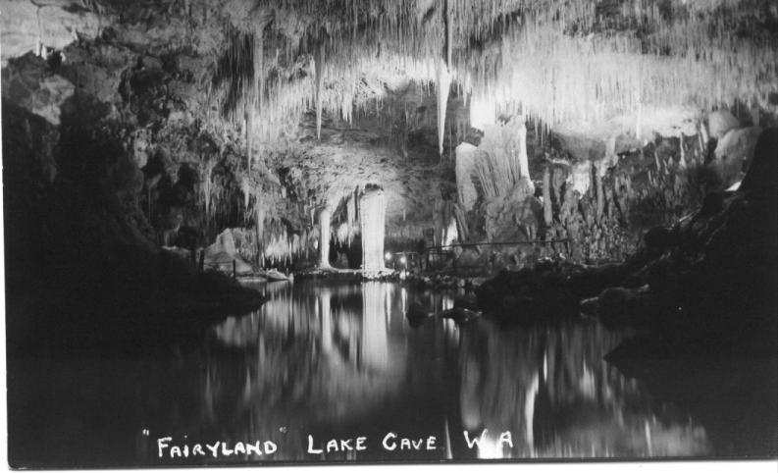
Lake Cave. Margaret River. W.A. V K-D(4)
Suspended Table, Lake Cave. W.A. V K-D(4)
"The Wishing Well", Lake Cave. W.A. K-D

